**Иванычу от Керила**

**ЗАДАНИЕ 2**. Дано интервальное распределение частот некоторой совокупности относительно признака X :

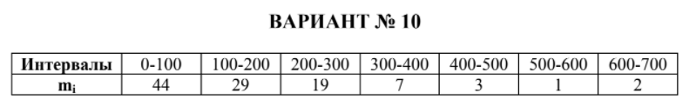

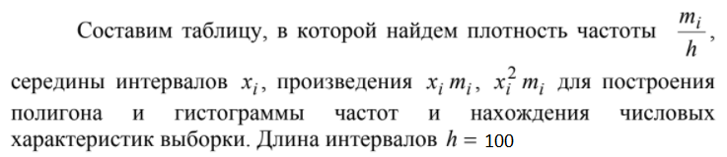

|  |  |  |  |  |  |
| --- | --- | --- | --- | --- | --- |
| ai - ai+1 | xi | mi | mi/h | ximi | xi^2mi |
| 0-100 | 50 | 44 | 0,44 | 2200 | 110000 |
| 100-200 | 150 | 29 | 0,29 | 4350 | 652500 |
| 200-300 | 250 | 19 | 0,19 | 4750 | 1187500 |
| 300-400 | 350 | 7 | 0,07 | 2450 | 857500 |
| 400-500 | 450 | 3 | 0,03 | 1350 | 607500 |
| 500-600 | 550 | 1 | 0,01 | 550 | 302500 |
| 600-700 | 650 | 2 | 0,02 | 1300 | 845000 |
| ∑ |  | n = 105 |  | 16950 | 4562500 |

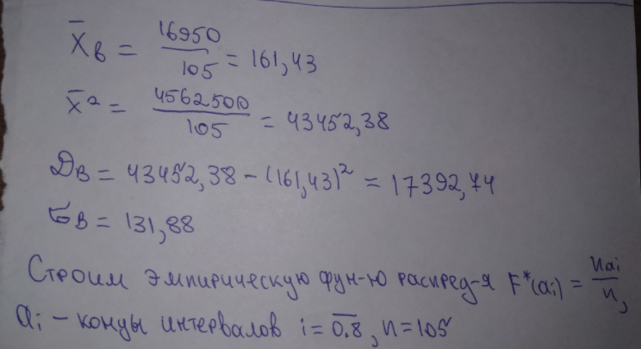

|  |  |  |  |  |  |  |  |  |
| --- | --- | --- | --- | --- | --- | --- | --- | --- |
| ai | 0 | 100 | 200 | 300 | 400 | 500 | 600 | 700 |
| F*(ai) | 0 | 0,419 | 0,695 | 0,876 | 0,943 | 0,971 | 0,981 | 1 |

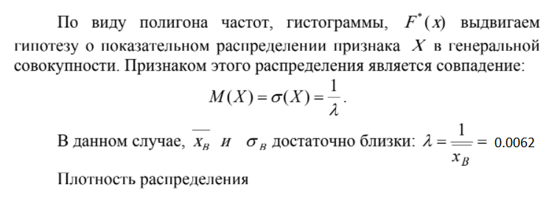

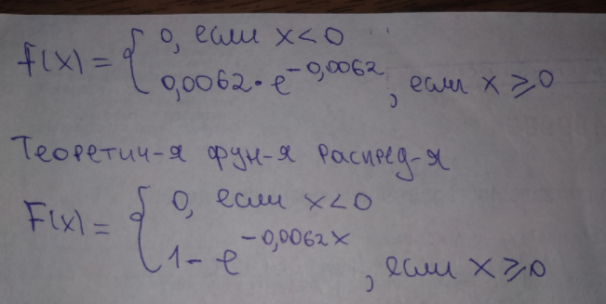

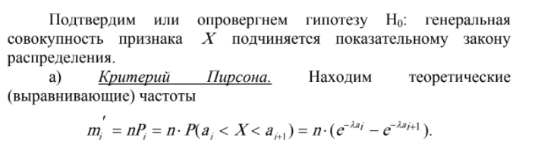

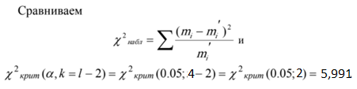

|  |  |  |  |  |  |
| --- | --- | --- | --- | --- | --- |
| Интервалы | Pi = e^(-0,0062ai) - e^(-0,0062ai+1) | mi' = 105Pi | mi | |mi - mi'| | (mi - mi')^2 / mi' |
| 0-100 | 0,4621 | 48,520 | 44 | 4,52 | 0,421 |
| 100-200 | 0,2485 | 26,090 | 29 | 2,91 | 0,325 |
| 200-300 | 0,1337 | 14,040 | 19 | 4,96 | 1,752 |
| 300-400 | 0,072 | 7,56 + +4,05+ +2,2+ +1,18= 14,99 | 7 3 1 2 | 1,99 | 0,264 |
| 400-500 | 0,0386 |
| 500-600 | 0,0209 |
| 600-700 | 0,0112 |
| ∑ | 0,987 | 103,640 | 105 | 14,38 | χ набл = 2,762 |

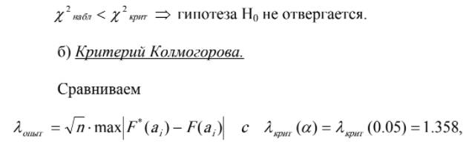

n = 105. F(ai) = 1 – e^(-0,0062ai) 

|  |  |  |  |
| --- | --- | --- | --- |
| ai | F*(ai) | F(ai) | |F*(ai) - F(ai)| |
| 0 | 0 | 0,000 | 0,000 |
| 100 | 0,419 | 0,462 | 0,043 |
| 200 | 0,695 | 0,711 | 0,016 |
| 300 | 0,876 | 0,844 | 0,032 |
| 400 | 0,943 | 0,916 | 0,027 |
| 500 | 0,971 | 0,955 | 0,016 |
| 600 | 0,981 | 0,976 | 0,005 |
| 700 | 1 | 0,987 | 0,013 |

max |F*(ai) - F(ai)| = 0,043, λопыт = sqrt(105) * 0.043 = 0.441



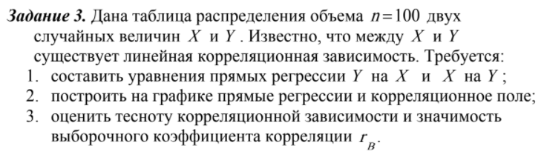

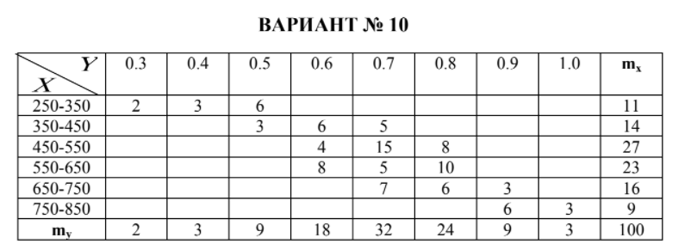

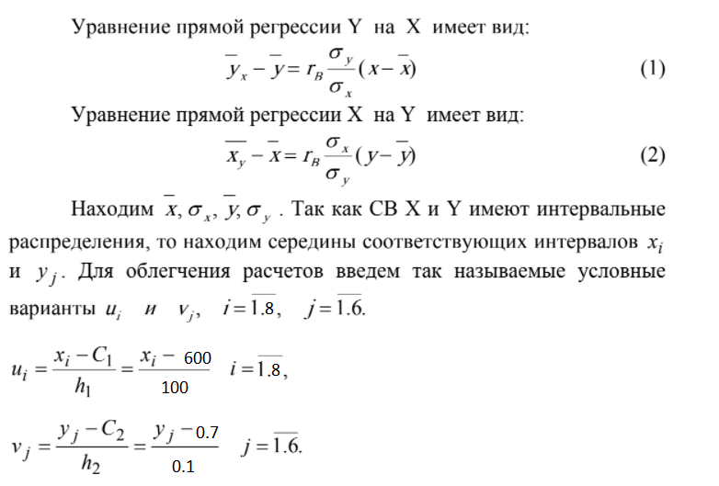

|  |  |  |  |  |  |
| --- | --- | --- | --- | --- | --- |
| Интервалы Х | xi | ui = (xi - 600) / 100 | mx | uxmx | ui^2mx |
| 250 - 350 | 300 | -3 | 11 | -33 | 99 |
| 350-450 | 400 | -2 | 14 | -28 | 56 |
| 450-550 | 500 | -1 | 27 | -27 | 27 |
| 550-650 | 600 | 0 | 23 | 0 | 0 |
| 650-750 | 700 | 1 | 16 | 16 | 16 |
| 750-850 | 800 | 2 | 9 | 18 | 36 |
| ∑ |  |  | 100 | -54 | 234 |

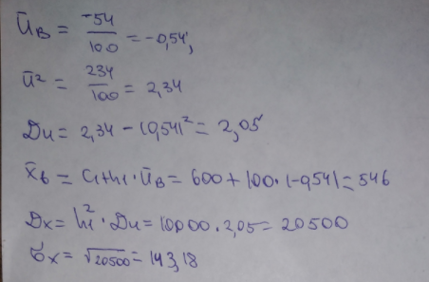

|  |  |  |  |  |  |
| --- | --- | --- | --- | --- | --- |
| Интервалы Y | yi | vi = (yi - 0,7) / 0,1 | my | vjmy | vj^2my |
| 0,3 | 0,3 | -4 | 2 | -8 | 32 |
| 0,4 | 0,4 | -3 | 3 | -9 | 27 |
| 0,5 | 0,5 | -2 | 9 | -18 | 36 |
| 0,6 | 0,6 | -1 | 18 | -18 | 18 |
| 0,7 | 0,7 | 0 | 32 | 0 | 0 |
| 0,8 | 0,8 | 1 | 24 | 24 | 24 |
| 0,9 | 0,9 | 2 | 9 | 18 | 36 |
| 1 | 1 | 3 | 3 | 9 | 27 |
| ∑ |  |  | 100 | -2 | 200 |

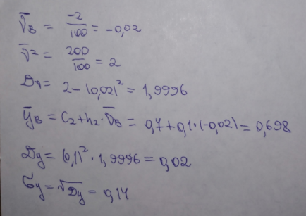

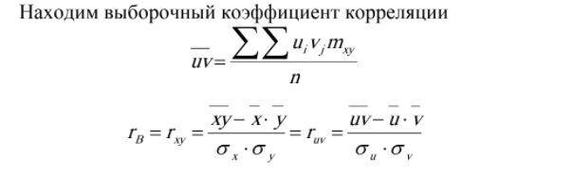

|  |  |  |  |  |  |  |  |  |  |  |
| --- | --- | --- | --- | --- | --- | --- | --- | --- | --- | --- |
| **vj**  **ui** | -4 | -3 | -2 | -1 | 0 | 1 | 2 | 3 | mx | ui ∑vj mxy |
| -3 | 2 | 3 | 6 |  |  |  |  |  | 11 | -3*(-8-9-12) = 87 |
| -2 |  |  | 3 | 6 | 5 |  |  |  | 14 | -2*(-6-6) = 24 |
| -1 |  |  |  | 4 | 15 | 8 |  |  | 27 | -1*(-4+8) = -4 |
| 0 |  |  |  | 8 | 5 | 10 |  |  | 23 | 0 |
| 1 |  |  |  |  | 7 | 6 | 3 |  | 16 | 1*(6+6) = 12 |
| 2 |  |  |  |  |  |  | 6 | 3 | 9 | 2*(12+9) = 42 |
| my | 2 | 3 | 9 | 18 | 32 | 24 | 9 | 3 | 100 | ∑1 = 161 |
| vj ∑ ui*mxy | -4*(-6) = 24 | -3*(-9) = 27 | -2*(-18-6) = 48 | -1*(-12-4) = 16 | 0 | 1*(-8+6) = -2 | 2*(3+12) = 30 | 3 * (6) = 18 | ∑2 = 161 |  |

